How do I create a Parent account if I am not an Athlete or Official?
- As part of the new USA Swimming Memberships, parents need to create their own account. This account is not required to register with their child's club. You will not use the club registration link for this account. You will need to go to hub.usaswimming.org. Here you will see a 'Login' screen.
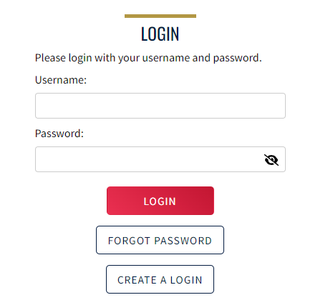
- Once you click on the 'Create A Login' button where you will then be taken to the 'Create A Login Screen:
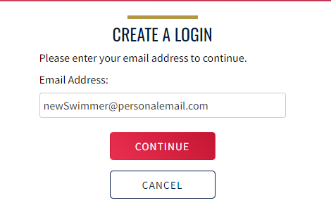

- Here you will need to fill in your personal email address and click the 'Continue' button. Once you click the 'Continue' button, you will be sent a verification code via email. The email will look like the picture below. Please check your spam/junk folder if you do not see the email in your inbox.
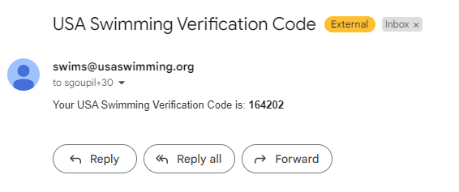
- On the USA Swimming site you will be taken to the following 'Verification'
screen. This is where you will enter the verification code that you received in your email.
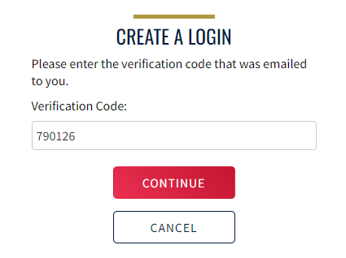

- Once you click the ‘Continue’ button you will be taken to the next step of creating your new username and password, as well as confirming your password:
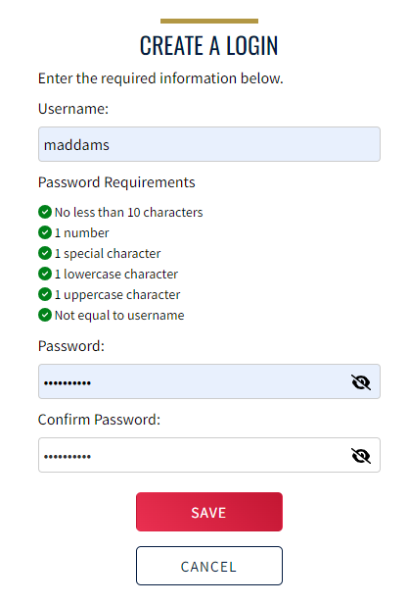
- Once you click on the 'Save' button you will then be taken back to the 'Login' screen where you will enter your new username and password and click the 'Login' button:
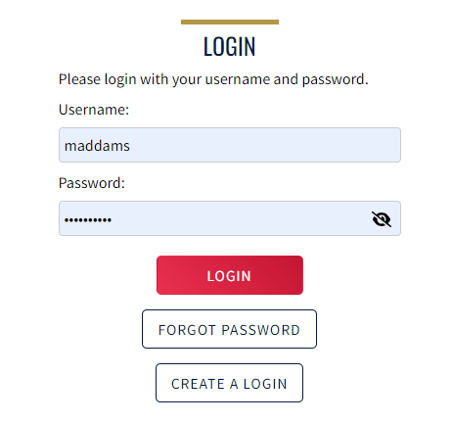

- Once you click on the 'Login' button, you will then be take to the 'Finalize Login' screen: 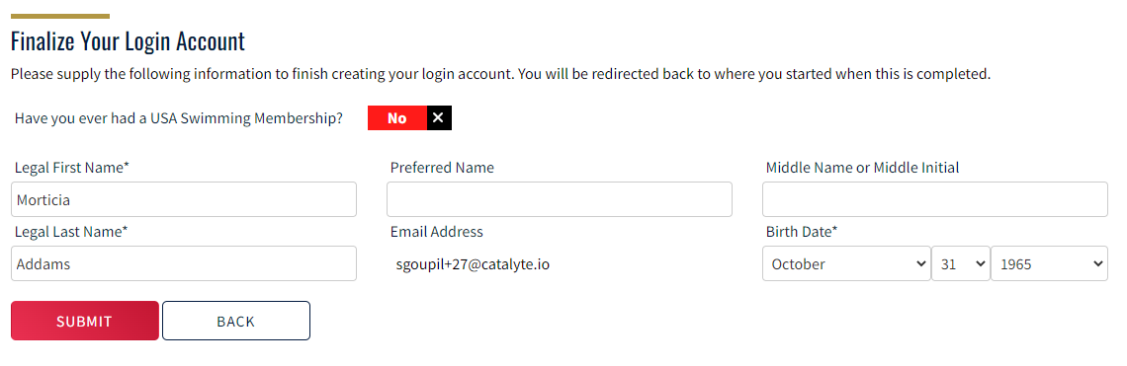
Here you will see the question 'Have you ever had a USA Swimming Membership?' and if you the parent has never had a USA Swimming membership, you will need to click that toggle button to 'No'. You will then fill in the required information and click the 'Submit' button. Once you click the 'Submit' button, you will then be taken to the 'Legal Acknowledgements' screen: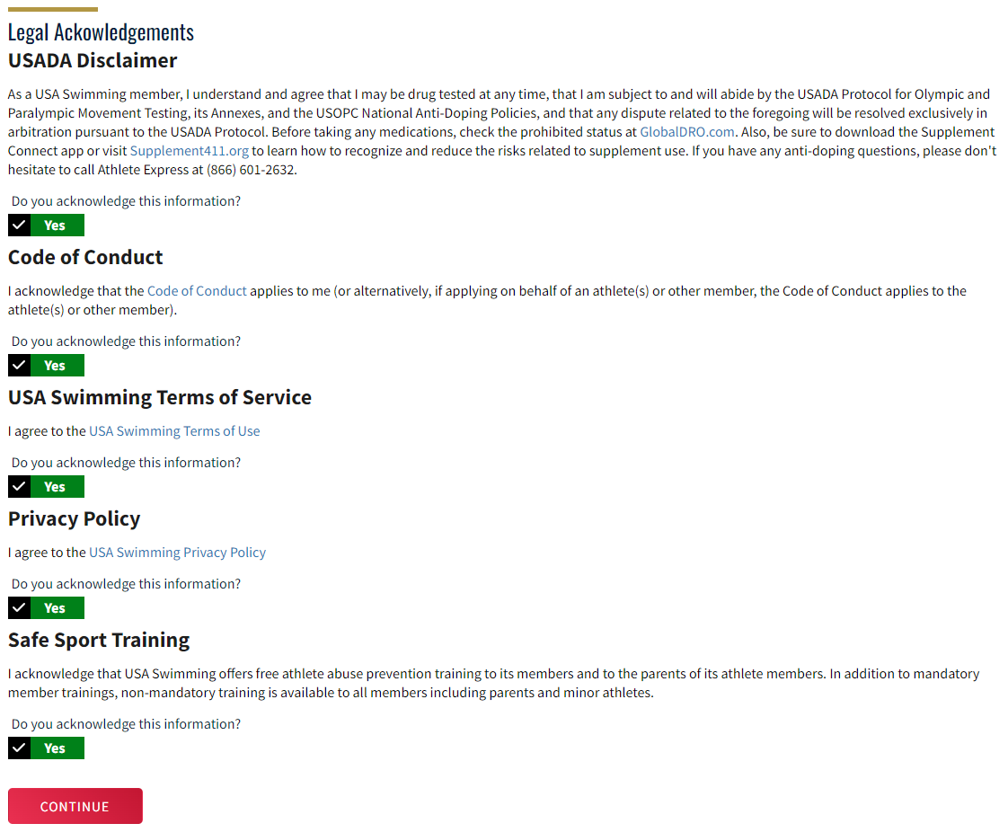
You will need to click 'Yes' on all of the toggle buttons in order to continue. Once you have clicked 'Yes' on all of the toggle buttons you will be able to click the 'Continue' button. After you click the 'Continue' button you will be taken to the 'Parent Dashboard' screen.
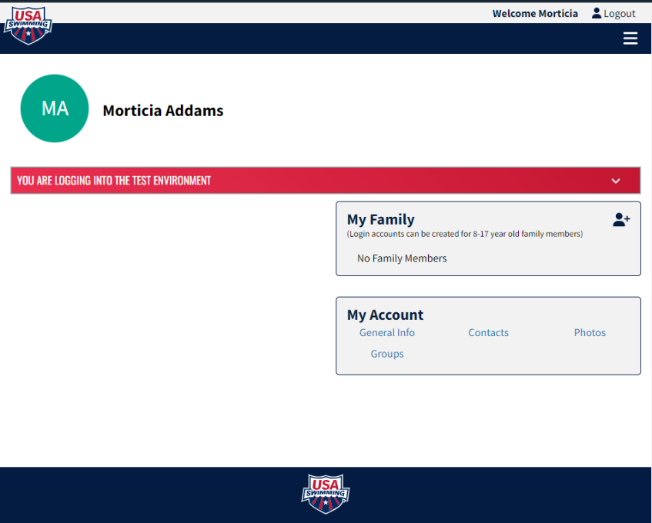
From this page you are able to add your family members to your 'My Family' section or you can go through your club registration link to register your family members.
Please be aware: If you add your family members (swimmers) through here, you will need their new Member ID from your Club Admin or from Ozark’s Registrar (registrar@ozarkswimming.com). Adding them here does NOT register them with USA Swimming. In order to register them with USA Swimming, you will need to follow the instructions for “Registering Your Swimmer with USA Swimming.” This will add them automatically to your ‘My Family’ section, and you will not need to know their Member ID number.

